INDIAN SCHOOL AL WADI AL KABIR
TERM 1: Chapter 4- Introducing Western Sociologists
(GRADE XI)
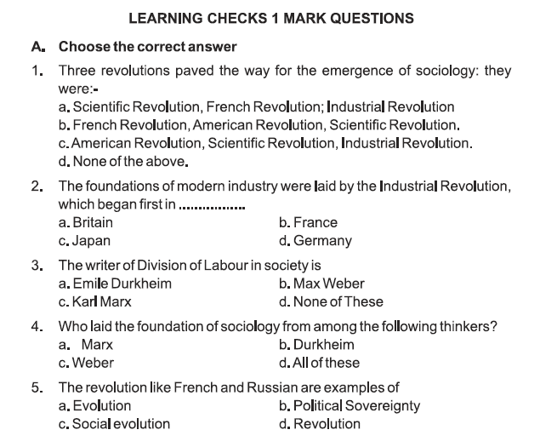
NOTES AND Q&A

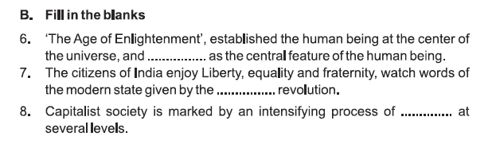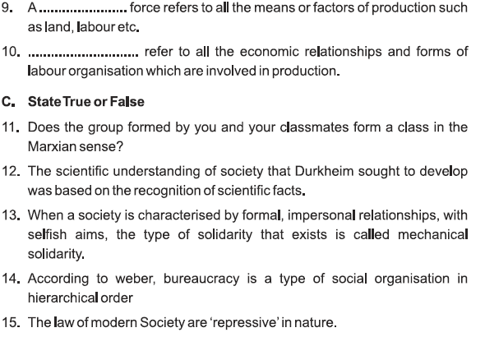
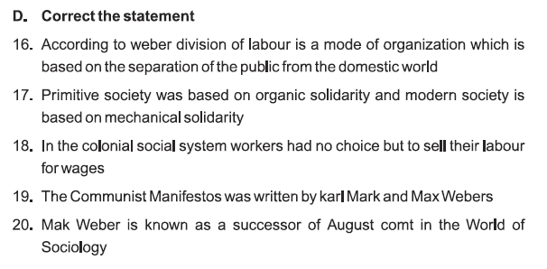
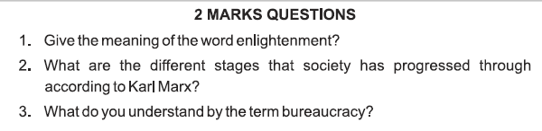
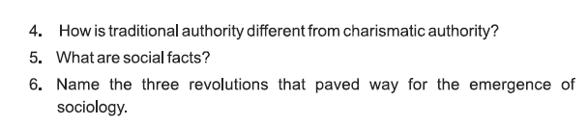

ANSWERS:

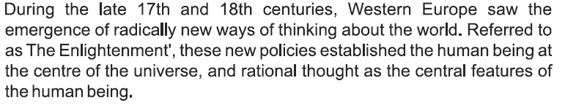
- The different stages that human society has progressed through according to Karl Marx are as follows: primitive communism, slavery, feudalism and capitalism. He believed that capitalism would ultimately give way to socialism.

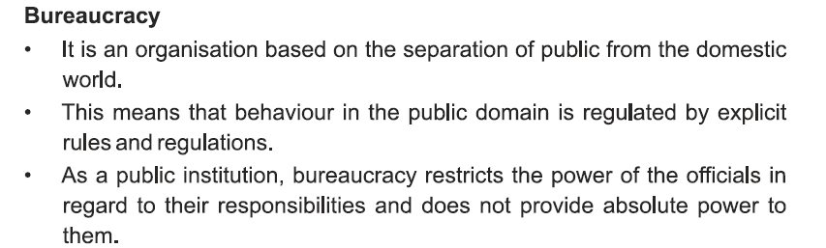
- Difference between traditional and charismatic authority…

5.
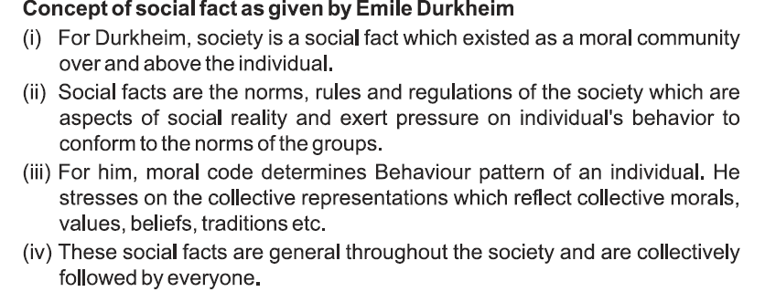

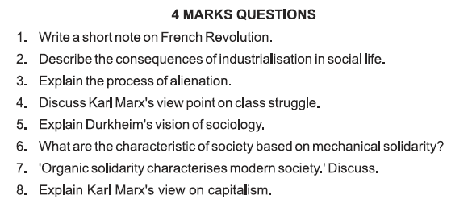

ANSWERS:

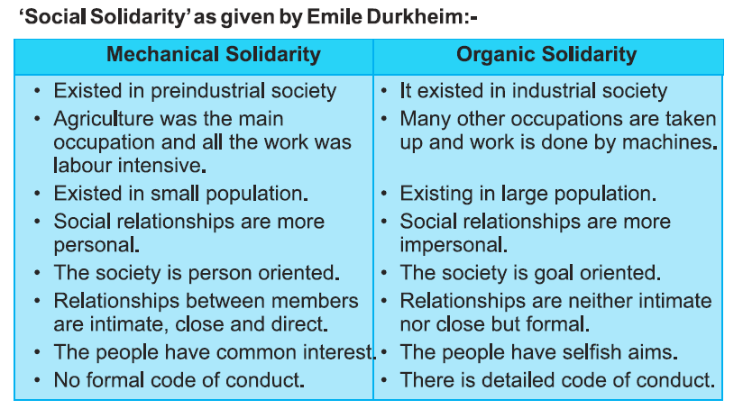
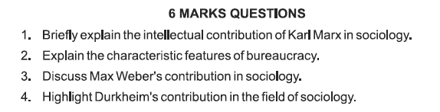

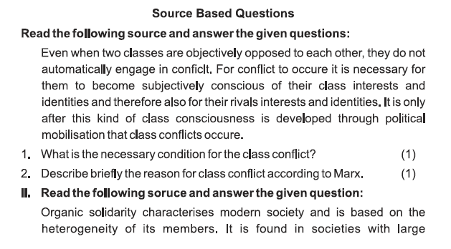
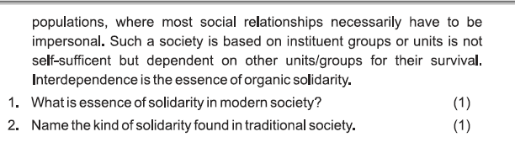

NCERT QUESTIONS:

Question 1: Why is the Enlightenment important for the development of sociology?
Answer:
- During the late 17th and 18th centuries, Western Europe saw the emergence of radically new ways of thinking about the world. It is referred to ‘The Enlightenment’.
- The ability to think rationally and critically transformed the individual human being into both the producer and the user of all knowledge, the ‘knowing subject’.
- Only persons who could think and reason could be considered as a complete human being.
- To become the definite features of the human world, it was necessary to displace nature, religion and the divine acts of gods from the central position they had in earlier days of understanding the world.
Question 2: How was the Industrial Revolution responsible for giving rise to sociology?
Answer:
- Production moved out of houses and went over to factories. People left their rural areas and went over to urban areas to find jobs in newly established industries
- Rich people started to live in large mansions and labour class started to live in slums.
- Due to modern administrative system, monarchy was forced to take the responsibility of public subjects and public welfare.
Question 3: What are the various components of a mode of production?
Answer:
A mode of production has the following components:
- First is the production forces or means of production i.e. land, natural resources, capital investment
- Second is the production relations. In a capitalist society, it was the class who owns the means of production or the bourgeoisie and the proletarians who were the labour class who produces goods, in exchange for wages.
Question 4: Why do classes come into conflict, according to Marx?
Answer: Karl Marx has studied two classes. Two opposite groups exist in each society.
First who does exploitation and second is that who is being exploited.
Conflict is always going on between these two classes from the very beginning.
- Bourgeoisie owns all the means of production and it suppresses other groups with his means of production.
- Second class is the labour class which was given the name of Proletariats.
Conflict is always going on between the exploiters and the exploited because capitalist hardly wants to give anything to labourer.
According to Marx, economic processes generally tend to generate class conflicts though this also depends on political and social conditions.
Question 5: Explain the term ‘Bourgeoisie’.
Answer: According to Marx, Bourgeoisie are those few people who own the means of production in a capitalist society. They enjoy both economic and political power.
Question 6: Explain the term ‘surplus value’.
Answer: The term ‘surplus value’ refers to the quality of value produced by the worker beyond the necessary labour time, i.e., the marking time required to produce a value equal to the one he has received in the form of wages.
Question 7: List two suitable grounds on which Marxian theory of class struggle has been criticized.
Answer: Karl Marx has absolutely ignored the middle class. Middle class has a great importance in modem society especially that society which can be called the supreme capitalist society.
The class struggle cannot be accepted as constructive. Hence, it is always destructive and it leads to fascism which any society is unable to bear.
Question 8: Discuss main contributions of Karl Marx.
Answer: Karl Marx was born in Trier, Germany on May 5,1818. Marx was educated at the Treves school. He obtained his doctorate from the University of Jena in June, 1841. Marx’s personal life was a difficult struggle. Marx died on 14th March, 1883.
Karl Marx says that each society has two opposite classes:
1. The exploiters (means capitalists) and
2. The exploited (means workers).
The term ‘surplus value’ refers to the quantity of value produced by the worker beyond the necessary labour time i.e., the working time required to produce a value equal to the one he has received in the form of wages.
The term ‘alienation’ refers to the word alien, which means foreigner, and therefore alienation would mean becoming stranger to one’s own people and the product etc. In a capitalist society, alienation dominates every institutional sphere such as religion, economy and polity.
Question 9: Explain in detail Karl Marx’s theory of class struggle.
Answer: Karl Marx was of the view that:
- Human society passed through different stages of development viz primitive, communal, ancient, feudal and capitalist.
- Each stage is defined by a mode of production.
- The factors of production are in the hands of the “oppressors’, they control them; the “oppressed” are deprived of them.
- There is a conflict between the “haves” and the “have-nots”.
- When the proletariat becomes conscious and acquires revolutionary character, there is an overthrow of those in power or the bourgeoisie.
Try to find out what Marx and Weber wrote about India.
Answer:
- Marx argued that people’s ideas and beliefs originated from the economic system of which they were part.
- Marx laid great emphasis on economic structure and processes because he believed that they formed the foundation of every social system throughout human history.
- Marx believed that class struggle was the major driving force of change in society.
- Weber argued that the overall objective of the social sciences was to develop an ‘interpretative understanding of social action’.
- The central concern of the social sciences was with social action and since human actions necessarily involved subjective meanings, the methods of enquiry of social science also had to be different from the methods of natural science.
- The social world was founded on subjective human meanings, values, feelings, prejudices, ideals and so on.
- Social scientists had to constantly practice ’empathetic understanding’. But this investigation has to be done objectively.
- Sociologists are meant to describe, not judge, the subjective feelings of others.
DURKHEIM
What are social facts?
Answer:
- Social facts are collective representations which emerge from the association of people.
- They are not particular to a person but of a general nature, independent of the individual.
- Durkheim called the ’emergent level’, that is the level of complex collective life where social phenomena can emerge.
- One of Durkheim’s most significant achievements is his demonstration that sociology, a discipline that dealt with abstract entities like social facts/could nevertheless be a science founded on observable empirically verifiable evidence.
- The most famous example of his use of new kind of empirical data is in his study of suicide.
- Each individual case of suicide was specific to the individual and his/her circumstances.
What is the difference between ‘mechanic’ and ‘organic’ solidarity?
Answer:
Durkheim says that in every society some values, ideas, beliefs, ways of behaviour, institutions and laws are there which binds the society in a single knot. Because of the presence of these elements, the relations and unity or solidarity exist in society.
He classified a society by the nature of social solidarity which existed in the society which are as follows:
Mechanical Solidarity
- It is predominant in less advanced societies.
- It is segmental in nature.
- In these social bonds are relatively weak.
- It exists more where population is less.
- In it, collective authority is absolute.
- It is highly religious.
- It is concrete and specific.
Organic Solidarity
- It is predominant in more advanced societies.
- It is organized in nature.
- In this, the social bonds are strong.
- It exists where population is more.
- In this, there is more room for individual initiative.
- It is highly secular.
- It is abstract and general.
Discuss Durkheim’s concept of collective conscience.
Answer:
- The concept of collective conscience is defined by Emile Durkheim as ‘the body of beliefs and sentiments common to the average of members of the society. It contains those beliefs and sentiments which are found in the average members of society, e.g., it is people’s belief that poor should not be tortured, instead people should take care of them.
- It comprised a form and content which varies according to whether society is characterized by mechanical or organic solidarity.
- According to mechanical solidarity the collective conscience is extensive and strong widely related to people’s life. It controls the people through various religious or other traditional means of sanction.
- It emphasizes the primacy of society over the individual and his or her dignity.
- Gradually the collective conscience declined in its influence and became less extensive.
- In the transition to organic solidarity this could be observed in the replacement of repressive by restitutive i.e., making amends of it by systems of law.
- According to Durkheim, a society wide collective conscience can only hold a segmental society together.
- The collective conscience becomes a diffuse, abstract cult of the individual which as a civil religion, supplies ultimate principles and justifications but cannot bear the whole weight of social cohesion.
- Durkheim believes that collective conscience is in the beliefs and expresses itself in the form of symbols, e.g., the festival of Vijayadashmi represents the victory of good over evil. This belief can be seen in the concrete form in this festival.
- The individual consciousness becomes subset of collective consciousness and therefore any violation of collective consciousness is labelled as revolt against whole society.
- The influence of collective consciousness varies from society to society. It is more prevalent among mechanical societies, i.e., less advanced and highly religious societies. Its influence declines in the organic society, i.e., advanced societies which are highly secular.
- The collective consciousness gets transferred from generation to generation through the process of socialization.
What are the basic features of bureaucracy?
Answer:
- Officials have fixed areas of official jurisdiction governed by rules, laws and administrative regulations.
- Commands are issued by higher authorities for implementation by subordinates in a stable way, but the responsibilities of officials are strictly delimited by the authority available to them.
- Official positions in a bureaucracy are independent.
- Authority and office are placed on a graded hierarchy where the higher officials supervise the lower ones.
- Management of a bureaucratic organization is carried out on the basis of written documents (the
- files) which are preserved as records.
- Full time attention of officials irrespective of her/his delimited hours in office, hence an official’s conduct in office is governed by exhaustive rules and regulations.
What is special or different about the kind of objectivity needed in social science?
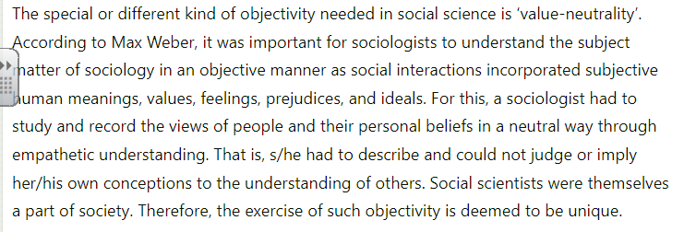
Explain briefly social fact as interpreted by Durkheim.
Answer: Social facts are those ways of thinking, doing work and feel which has the special characteristics to maintain its existence exterior to the individual consciousness. Durkheim also writes, “Social facts are those ways of working, thinking and feeling which are exterior to man and which controls the man by their power of constraint”.
Why is Emile Durkheim called the ‘key classical theorists in sociology’?
Answer: Emile Durkheim is one of the ‘key classical theorists in sociology’. He is best known for founding sociology as a scientific discipline and for defining the boundaries of its subject matter. His key theoretical statement lies in his claim that social phenomena are realities that can only be explained by other social facts.
Differentiate between the sacred and the profane.
Answer: The sacred is that which is considered holy and dreaded. It includes religious beliefs and rites, duties or anything related to religious treatment par excellence.
The profane relates to the ordinary, utilitarian aspects of life, dull or routine, full of impurity.
Write short note on Max Weber.
Answer: Max Weber was born on 21st April, 1864 in Erfurt, Germany. He studied and received his degree in law. After the completion of his doctoral and the post-doctoral dissertations in 1897 he joined Heidelberg University as a Professor of Economics. He started his works in sociology in 1916 and was appointed Professor of Sociology at Munich. He died on July 14,1920. His main works include:
- The Protestant Ethic and Spirit of Capitalism
- The Religion of India.
- Economy and Society
- Essays in Sociology
Write a short note on Emile Durkheim.
Answer: Emile Durkheim was born on 15th April, 1858 in France. His elementary education was completed at Ecole. After graduation from the Ecole, he started working for the
doctoral degree. He obtained his doctorate in 1893, and was appointed Professor in the Paris University. Durkheim founded L ‘Anne Sociologique, the first social science journal in France. He died on Nov. 15,1917. His works include:
- Division of Labour in Society
- The Rules of Sociological Method
- Suicide
- The Elementary Forms of Religious Life.
According to Durkheim, social facts are the substance of sociological study. Durkheim was strongly concerned with outlining the nature and scope of sociology.
- They are general throughout society.
- They are external to individuals and exist independently on their will.
- They exercise external constraint over individuals.
Highlight the basic characteristics of religion according to Durkheim.
Answer: The basic characteristics of religion are:
- Belief in supernatural power.
- Emotional state of mind associated with the beliefs, happiness, fear, reverence etc.
- Material objects involved in the religious practices-altar, cross, sacrifice, flower, . incense sticks, special clothes, banana leaves etc.
- Variations in the types of material objects used in religious ceremonies-differ from culture to culture.
- Specific rituals – fasting, chanting, dancing, specific types of food etc.
- Specific mode of worship.
- Concept of heaven and hell; sacred and profane etc.
- A special place of worship.
- Generally, rituals are performed in isolation but occasionally it is performed collectively.
How did Max Weber explain “social action”? Elaborate on the types of social action seen in society. (HOTS)
Answer: According to Max Weber
- An action is social when it is oriented or directed to others in society.
- It is social in so far as by virtue of the meaning attached to it by the acting individual or individuals.
- All human behaviour to which the actor attaches a subjective meaning is social action.
Types of social action
- Goal-Rational Action: Both means and goals are rationally selected by the individual.
- Value-Rational Action: These are performed under the influence of ethical values and religious beliefs of the individual.
- Emotional Action: The means and ends of the action are selected on the basis of emotional criteria. They may not be rational.
- Traditional Action: Tradition and customs guide the selection of the means and ends.

